TODO:

* Decide who our audience is (
* What exactly is our topic (wastewater treatment? Sewers? Public toilets? etc.)
* What features our map will have

### Concept Overview: Sanitation Infrastructure Mapping

The goal of this interactive map is to visualize the availability, condition, and effectiveness of sanitation infrastructure across Korea. It will focus on key sanitation components like wastewater treatment plants, sewer networks, public toilets, and other facilities critical to maintaining hygiene standards. The map will enable users to explore both urban and rural sanitation scenarios, helping to identify areas where resources need to be directed.

### Key Features and Data Layers

1. **Wastewater Treatment Plants (WWTPs)**
   * **Data to Display**:
     + Locations of all major wastewater treatment plants across Korea.
     + Information on each plant’s capacity (volume of water treated daily).
     + Current operational status (e.g., fully operational, under maintenance, or closed).
     + Type of treatment technology used (e.g., activated sludge, membrane bioreactors).
   * **Interactive Features**:
     + **Clickable Pop-ups**: When a user clicks on a treatment plant, a pop-up displays detailed information about the facility's treatment process, the pollutants it can handle, and any ongoing upgrade projects.
     + **Historical Data**: A timeline feature that shows past improvements, expansions, or issues the plant has faced.
2. **Sewer and Drainage Networks**
   * **Data to Display**:
     + Map layers showing the extent and density of sewer networks in urban versus rural areas.
     + Identification of combined sewers (handling both wastewater and stormwater) versus separated systems.
     + Indicators of areas experiencing frequent blockages, leaks, or overflows.
   * **Interactive Features**:
     + **Layer Toggle**: Users can toggle layers to view different types of sewers (stormwater drains, domestic sewage lines).
     + **Highlight Problem Areas**: Regions with recurring sewer problems could be highlighted in red, with specific issues listed (e.g., blockages, outdated pipes).
3. **Public Toilets and Sanitation Facilities**
   * **Data to Display**:
     + Locations of public toilets, categorized by accessibility (e.g., wheelchair accessible, gender-neutral).
     + Availability of hygiene facilities such as handwashing stations and water availability.
   * **Interactive Features**:
     + **User Ratings and Feedback**: Allow users to rate the cleanliness of public toilets and add comments about their experiences.
     + **Crowdsourced Reporting**: Citizens can report issues directly on the map, like broken fixtures or lack of soap, which could then be addressed by local authorities.
4. **Areas Lacking Sanitation Infrastructure**
   * **Data to Display**:
     + Highlight areas, particularly rural regions or informal settlements, that lack adequate sanitation facilities.
     + Display statistics on population density and the percentage of households without proper sanitation.
   * **Interactive Features**:
     + **Needs Assessment Tool**: Allow users to explore data about what kind of sanitation interventions (e.g., new sewers, portable toilets) are most needed in specific areas.
     + **Potential Projects Overlay**: Include information about planned government or NGO projects aimed at improving sanitation in these regions, with timelines for implementation.
5. **Environmental Impact Indicators**
   * **Data to Display**:
     + Data on untreated sewage discharge points, highlighting areas where wastewater directly impacts rivers, lakes, or coastal areas.
     + Information about the impact of sanitation on local ecosystems, including any reported cases of contamination affecting water bodies.
   * **Interactive Features**:
     + **Pollution Flow Visualization**: Use animation to show how untreated wastewater might flow into natural water sources during heavy rains, impacting nearby communities.
     + **Ecosystem Health Tracker**: Users can see the correlation between wastewater discharge locations and the health of nearby ecosystems (e.g., fish population decline, algal blooms).

### Advanced Interactive Features

1. **Real-time Monitoring and Alerts**
   * Integrate sensors or live data feeds from wastewater treatment facilities to show real-time performance metrics like flow rates, pollutant levels, and emergency overflows.
   * Enable users to subscribe to alerts for issues like system failures, maintenance shutdowns, or pollution incidents in their area.
2. **Comparative Analysis Tool**
   * Allow users to compare sanitation infrastructure between different regions or cities, showing gaps in service provision and highlighting best practices.
   * Visualization options to compare urban areas with rural zones, emphasizing disparities in sanitation access and quality.
3. **Investment and Resource Allocation**
   * A layer that shows where government and private sector investments are being directed to improve sanitation infrastructure.
   * **Interactive Budgets**: Users can click on a region to see how much funding has been allocated for sanitation improvements and the types of projects that money is supporting.
4. **Community Engagement and Education**
   * Include educational resources on the importance of sanitation, how treatment plants work, and how individuals can help improve sanitation in their communities.
   * **Interactive Quizzes and Polls**: Add features that engage users with quizzes about water and sanitation challenges, providing rewards for correct answers to promote learning.

### Potential Data Sources and Visualization Tools

1. **Data Sources**
   * **Governmental Agencies**: Data from the Ministry of Environment, local municipal water and sanitation departments, and statistical agencies.
   * **International Organizations**: Information from the World Health Organization (WHO), UNICEF, and other relevant bodies working on water and sanitation in Korea.
   * **Local NGOs**: Data from organizations involved in rural water supply and sanitation projects.
2. **Visualization Tools**
   * **GIS Software**: Use tools like ArcGIS or QGIS to handle geographic data and create dynamic map layers.
   * **Web Mapping Platforms**: Platforms like Mapbox or Leaflet.js can help build user-friendly, interactive online maps.
   * **Data Integration**: Use APIs to integrate real-time data from sensors or public databases directly into the map.

### User Interface Design Suggestions

* **Layer Control Panel**: Include a sidebar where users can easily toggle different layers (e.g., treatment plants, sewer networks, public toilets) to customize the data they want to see.
* **Color-Coding**: Use clear and intuitive color schemes to differentiate between areas with adequate sanitation infrastructure, areas needing improvement, and critical hotspots.
* **Search and Filter Functionality**: Allow users to search for specific locations or filter data by categories such as infrastructure type, capacity, or current status.

### Impact and Goals

The ultimate goal of this interactive map is to:

* Raise awareness about gaps in sanitation infrastructure.
* Help policymakers and stakeholders identify priority areas for investment.
* Provide the public with transparent information about sanitation services.
* Empower communities to engage in improving their local sanitation conditions.

# Problem Statement:

## Water scarcity is a big issue (Research 1)

* [South Korea grapples with one of its worst water scarcity crises](https://www.channelnewsasia.com/asia/south-korea-water-scarcity-drought-water-tanks-seafood-supply-affected-3385501) 
  + Summary of article:

South Korea is experiencing a **significant water shortage**, particularly in the southwestern Jeolla province, due to an **extended drought**. The lack of rainfall has severely impacted water supplies, forcing local governments to impose water restrictions and distribute water through tanks to affected residents. This crisis also **threatens agricultural production and the seafood industry**, as water scarcity affects both crops and fisheries.

The article highlights that residents are adapting by **using water tanks and limiting water use**, while local authorities warn that the situation could worsen if the drought persists. Additionally, water scarcity is disrupting industries that rely heavily on water, such as farming and seafood processing, exacerbating economic challenges in the region. This situation reflects broader concerns about climate change, as South Korea grapples with more frequent and intense droughts that strain infrastructure and the environment​

* [High groundwater depletion risk in South Korea in 2080s](https://www.sciencedaily.com/releases/2024/05/240530132631.htm)
  + Summary of article:

A recent study led by Professor Jonghun Kam from POSTECH warns that groundwater depletion could **affect approximately three million people in Korea by 2080**, particularly in the southwestern regions. The research, published in Science of the Total Environment, analyzed groundwater data from 2009 to 2020 using advanced statistical methods to reveal critical patterns.

The study found that shallow groundwater responds more to seasonal precipitation, while deep groundwater is more sensitive to droughts. Both types are essential for community water needs, especially in drought-prone areas. Alarmingly, groundwater levels in the western peninsula have shown a declining trend since 2009, posing long-term risks if overuse and urban development continue.

The researchers emphasize the need for integrated national water policies to **balance regional development and sustainable water management**, especially as climate change and rising land temperatures alter water flows. This approach will be vital in mitigating drought impacts and ensuring reliable access to groundwater in the future.

## Old and Outdated Water Infrastructures (Research 2)

* [South Korea’s water supplying infrastructures are old and outdated (old water pipes, etc)](https://www.me.go.kr/eng/web/index.do?menuId=465) 
  + Summary:

Korea's water supply system, while serving 99.1% of the population, relies on aging infrastructure that needs urgent upgrades. Many old pipes are being replaced to improve safety and efficiency. Current efforts focus on modernizing this infrastructure, particularly in rural areas, and incorporating smart technologies to enhance service reliability.

## Inefficient Water Management (Research 3)

* [Water Management Policy of the City of Seoul | 서울정책아카이브 Seoul Solution](https://www.seoulsolution.kr/en/content/3575)
  + Korea faces significant water management challenges due to aging infrastructure and high leakage rates, with Seoul losing about 5-6% of its water supply. Rural areas often lack access to clean water, highlighting inequalities in distribution. Inefficient resource allocation and outdated systems contribute to environmental and public health risks, while urban flooding during heavy rainfall reveals inadequate drainage. Overall, there's a pressing need for reform and investment to modernize water infrastructure and improve management practices.
* [Managing the Water-Energy-Land-Food Nexus in Korea | OECD](https://www.oecd.org/en/publications/managing-the-water-energy-land-food-nexus-in-korea_9789264306523-en.html)

## Water Pollution Hotspots

* **Polluted Rivers and Lakes:** Highlight areas like the Han River or Nakdong River that face pollution problems.
* **Industrial Areas:** Show clusters of factories and their impact on nearby water bodies.
* **Algal Bloom Alerts:** Identify areas where harmful algal blooms (HABs) occur due to rising water temperatures.

## Public Health and Water

* **Access to Clean Water:** Map regions with good vs. poor access to drinking water.
* **Waterborne Disease Risk Zones:** Identify areas with risks of contamination (e.g., during floods).
* **Boil-Water Advisories:** Mark places with recent advisories due to contamination risks.

# Old and Outdated Water Infrastructures

## Project Problem Statement

Ensuring public access to safe and clean drinking water is a critical issue for urban areas like Seoul, especially as the city faces challenges from both aging water infrastructure and inefficient management systems. Despite covering 99.1% of the population, Korea's water supply system suffers from old pipelines, which contribute to water leakage (5-6% in Seoul) and inefficiencies. The lack of real-time public access to water quality data further complicates monitoring efforts and leaves residents unaware of potential risks to sanitation. Additionally, rural areas remain underserved, facing both water quality and distribution challenges.

This project aims to bridge the gap in public water quality monitoring by developing an interactive map using APIs. The map will visualize key water parameters (e.g., pH levels, chlorine content) across different districts and highlight areas with infrastructure risks, such as old or high-leakage water pipes. By making water quality statistics accessible to residents and officials in real time, the project seeks to promote informed decision-making, improve public health, and encourage efficient resource management to address both water scarcity and infrastructure issues.

## Audience - Who can this info benefit?

* **Local residents - General public, homeowners, people looking for homes**
* Environmental activists, NGOs - Maybe
* Government officials/Urban planners - Maybe
* ~~Educators and students~~
* ~~Tourists and visitors~~ - Not really related, doesn’t really affect them

## Poster Outline

* table/graph about water info
* Map
* Problem identification
* Possible solution

### Title

### Introduction/Problem Definition

### Graph/Table: Water Information

### Map: Interactive Visualization

### Proposed Solutions

### Conclusion

### Visuals

QR-code to interactive map (if we have the website)

Infographics simplifying statistics

## Data Collection & Research

* [Challenges for water infrastructure asset management in South Korea](https://iwaponline.com/wp/article/21/5/934/68120/Challenges-for-water-infrastructure-asset)
  + Research paper with data about deterioration rates of water infrastructures
  + 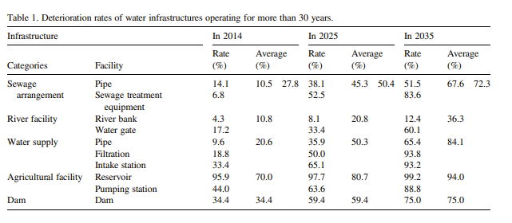
* [Analysis of groundwater contaminants by region](https://www.bigdata-map.kr/datastory/env/env2019#:~:text=%EC%88%98%EC%A7%88%20%EC%98%A4%EC%97%BC%EC%A7%80%EC%88%98%EA%B0%80%20%EA%B0%80%EC%9E%A5,%EC%98%A4%EC%97%BC%EC%A7%80%EC%88%98%EA%B0%80%20%EB%86%92%EA%B2%8C%20%EB%82%98%ED%83%80%EB%82%AC%EB%8B%A4.)
  + Map of groundwater information indifferent areas of Korea with specific information about hydrogen ion concentration (pH), total coliform bacteria, nitrate nitrogen, and chlorine ion
  + 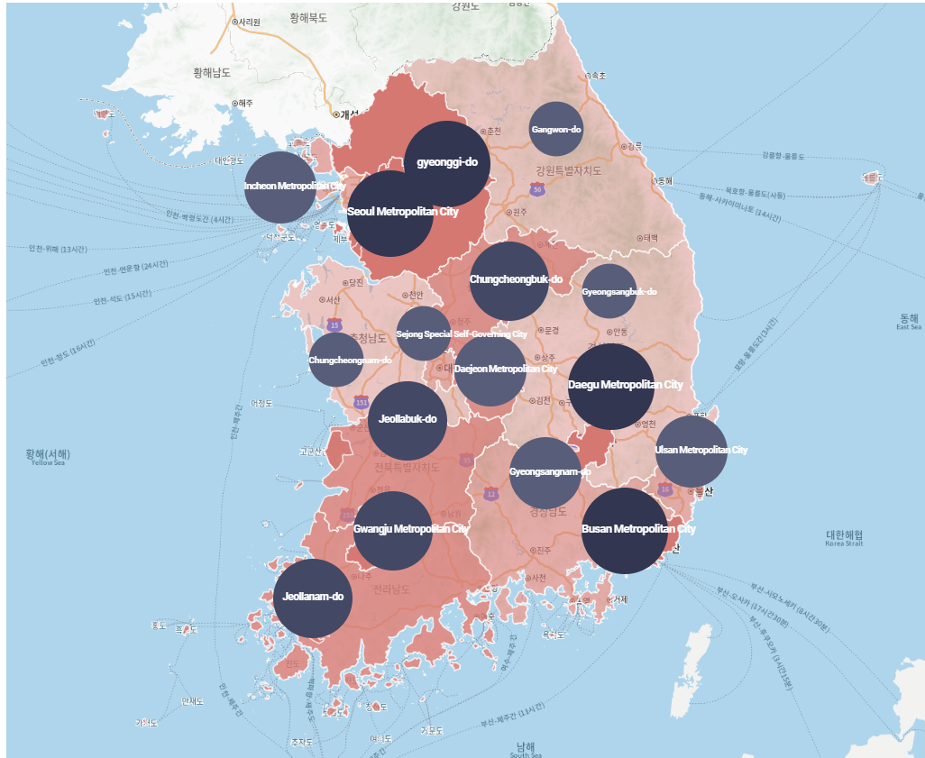
* Seoul ([[국토매일] [기획] 노후 상수도관 국민생명 위협… 수질과 배관 청결이 관건](https://www.pmnews.co.kr/97861))
  + “The water supply system that produces drinking water, which is essential to our lives, has been hit by a **series of pipe ruptures in Seoul last month**. On September 20, a large pipe ruptured and caused a leak at the intersection in front of the National Police Agency in Sunhwa-dong, Jung-gu, Seoul, and on the 25th, a similar accident occurred at the intersection of Seodaemun Station.”
  + “The amount of tap water being wasted like this is enormous. It has been investigated that **the amount of water leakage over the past five years has reached 132 million tons**.”
  + “However, according to the Seoul Metropolitan Government, there were 8,399 water leak incidents last year, and the amount of water leaked was 840,000 tons. This is only 3% of the total amount of water leaked, which is 28 million tons. Regarding this, former Assemblyman Jeon said, “This means that the remaining 97% is disappearing into the ground without any known cause.”
  + Maybe use as future resource: 서울시 누수발생 현황
* Busan ([부산지역 생활 기반 시설 숫자 전국 최하위...노후화도 심각해](https://www.pressian.com/pages/articles/2021111609160570525))
  + “Among the existing living infrastructure facilities, the most aged facilities in terms of facility durability are the water supply and sewage facilities that are directly related to the health of citizens and require timely improvement. Among the water supply facilities, the first water purification plant of Myeongjang Water Purification Plant is seriously aged, having been completed 75 years ago.”

- Analysis information on contaminants in groundwater by region

- [Seoul City Water Quality Status Statistics](https://data.seoul.go.kr/dataList/342/S/2/datasetView.do)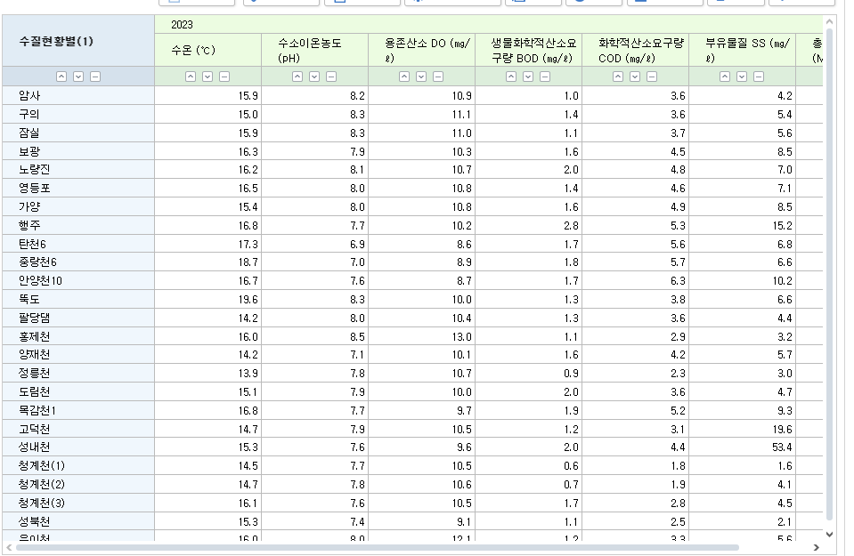

-[서울시 수돗물 수질검사 통계](https://data.seoul.go.kr/dataList/351/S/2/datasetView.do)

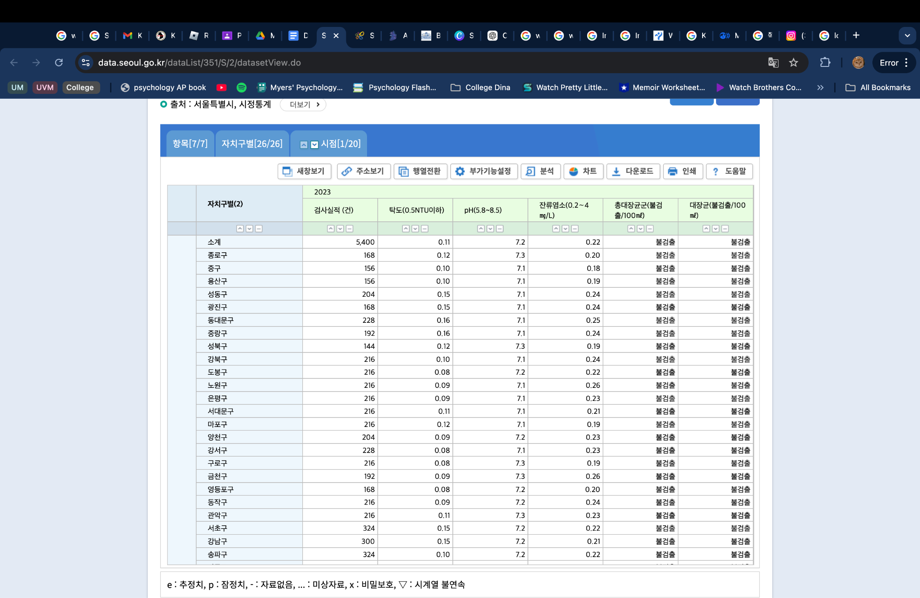

-<https://data.seoul.go.kr/dataList/OA-15488/S/1/datasetView.do>

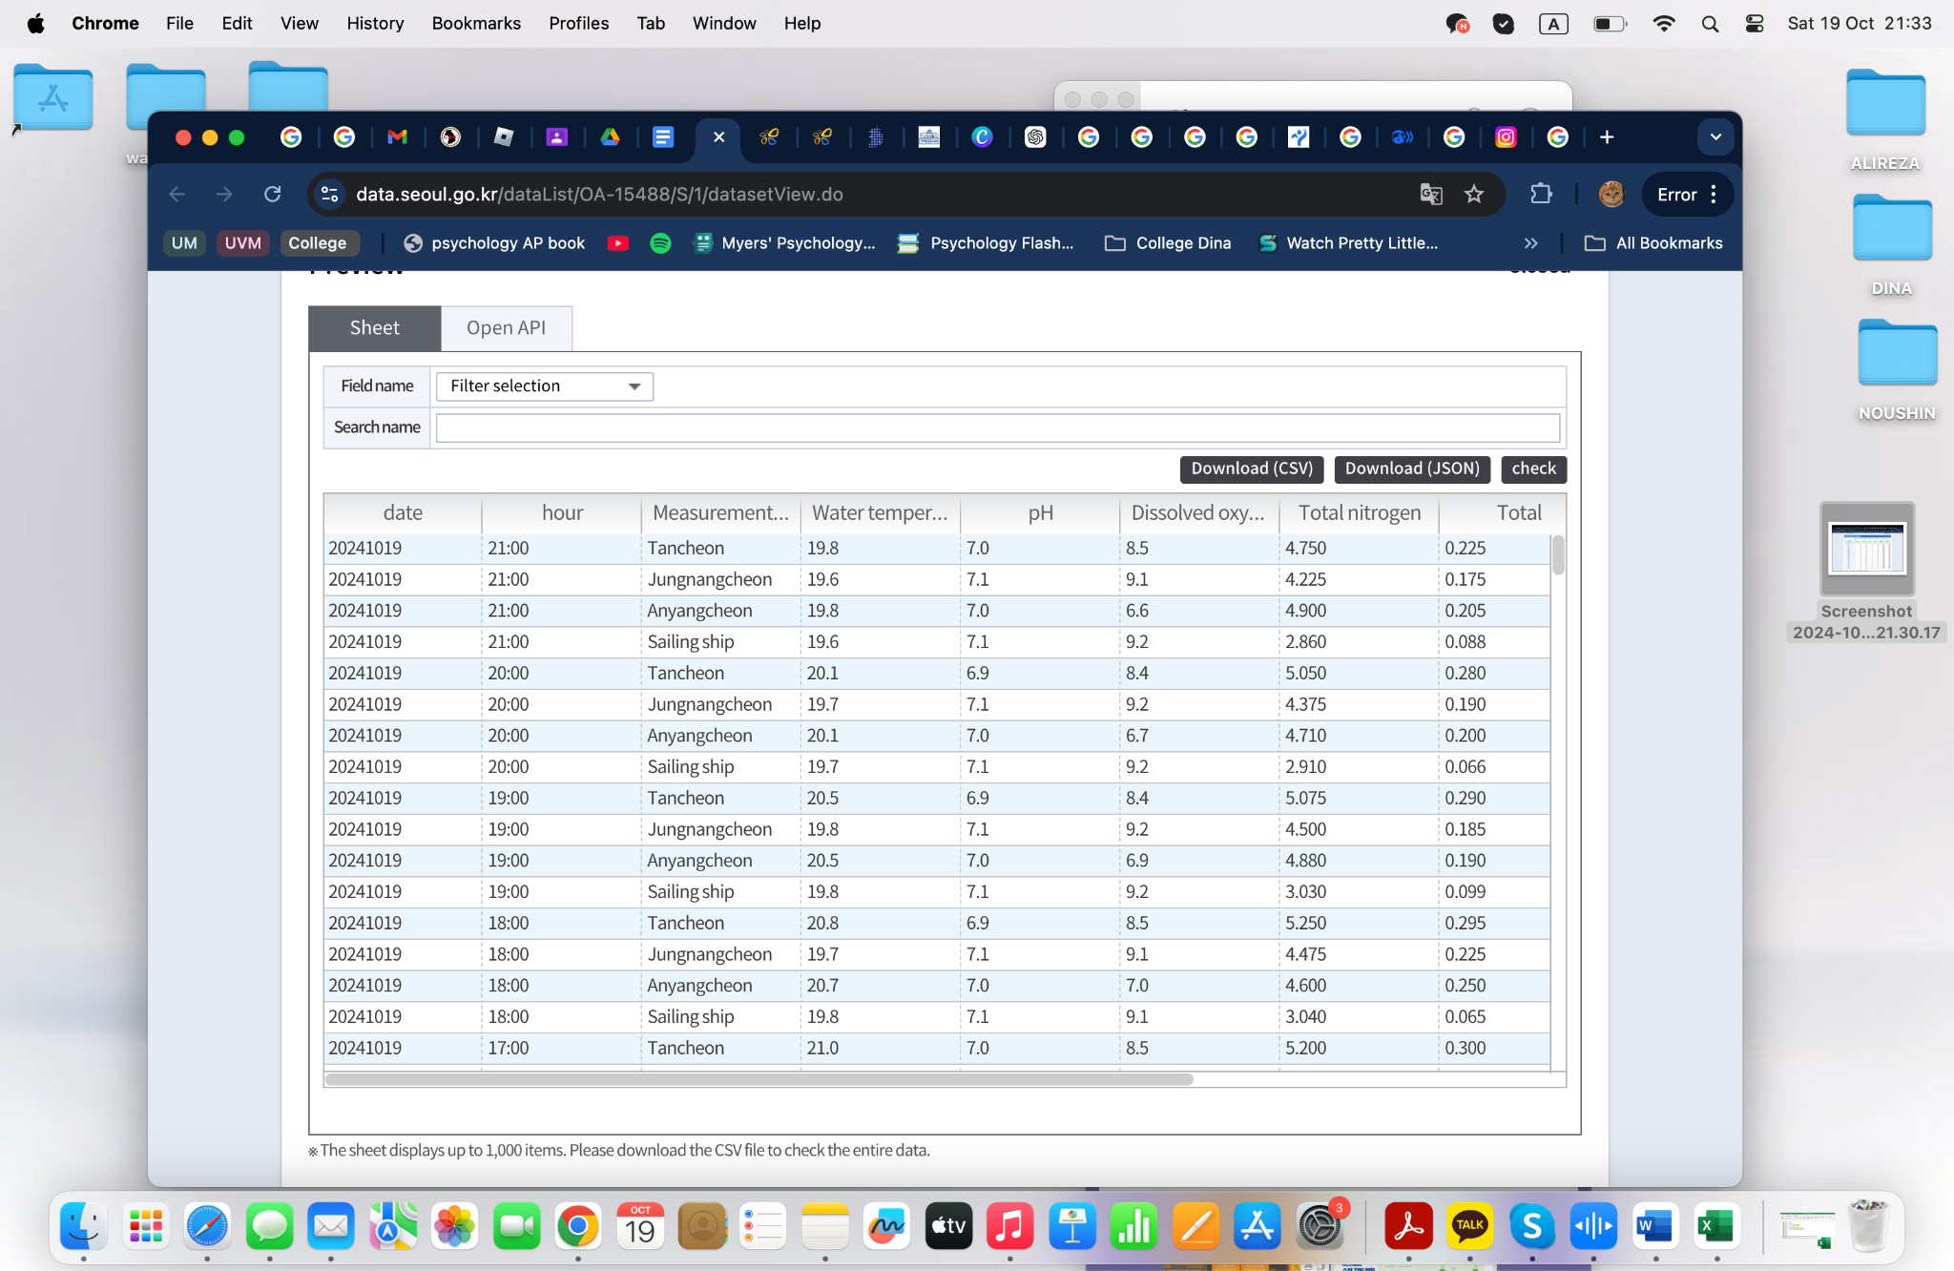

-<https://kosis.kr/statHtml/statHtml.do?orgId=106&tblId=DT_MLTM_1010&vw_cd=MT_ZTITLE&list_id=T_16&scrId=&seqNo=&lang_mode=ko&obj_var_id=&itm_id=&conn_path=MT_ZTITLE&path=%252FstatisticsList%252FstatisticsListIndex.do>

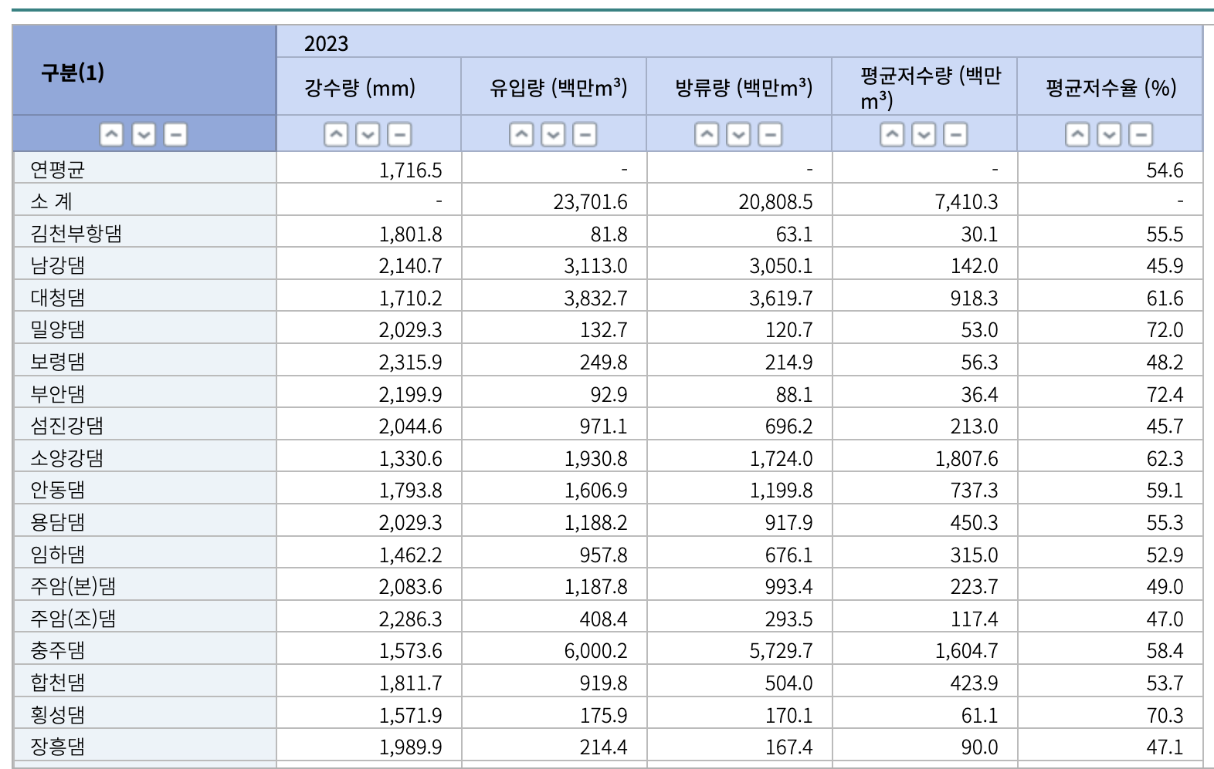

* - [해방촌](https://www.khan.co.kr/local/Seoul/article/202105200600001)/달동네 판자촌
  + 해방촌(Haebangchon) recently had an issue of reduced water flow in 2021 because of the old water pipes they had. However, they switched 18km of the old pipes with new ones

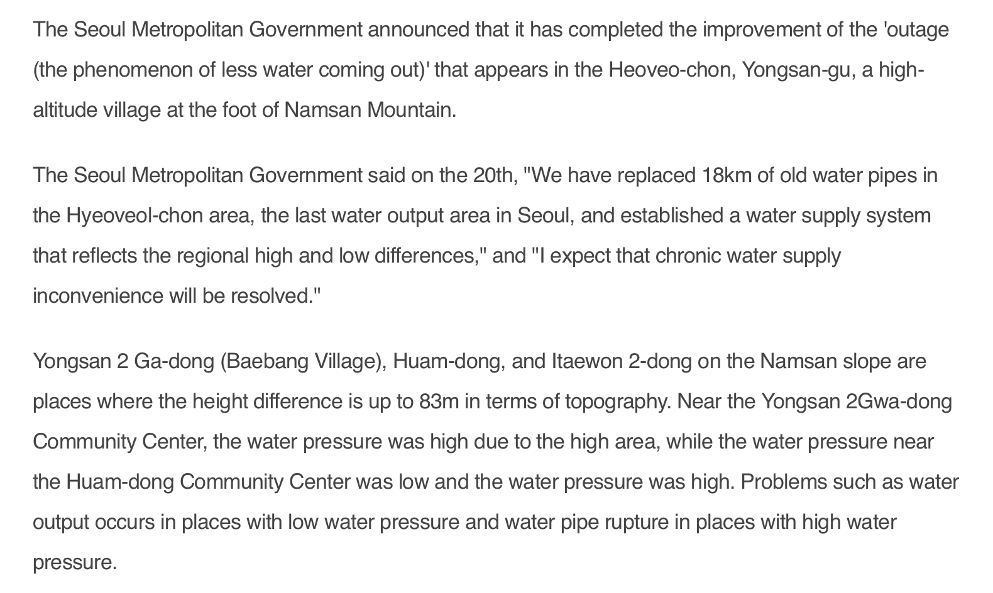

[물환경정보시스템 (nier.go.kr)](https://water.nier.go.kr/web#1stPage)

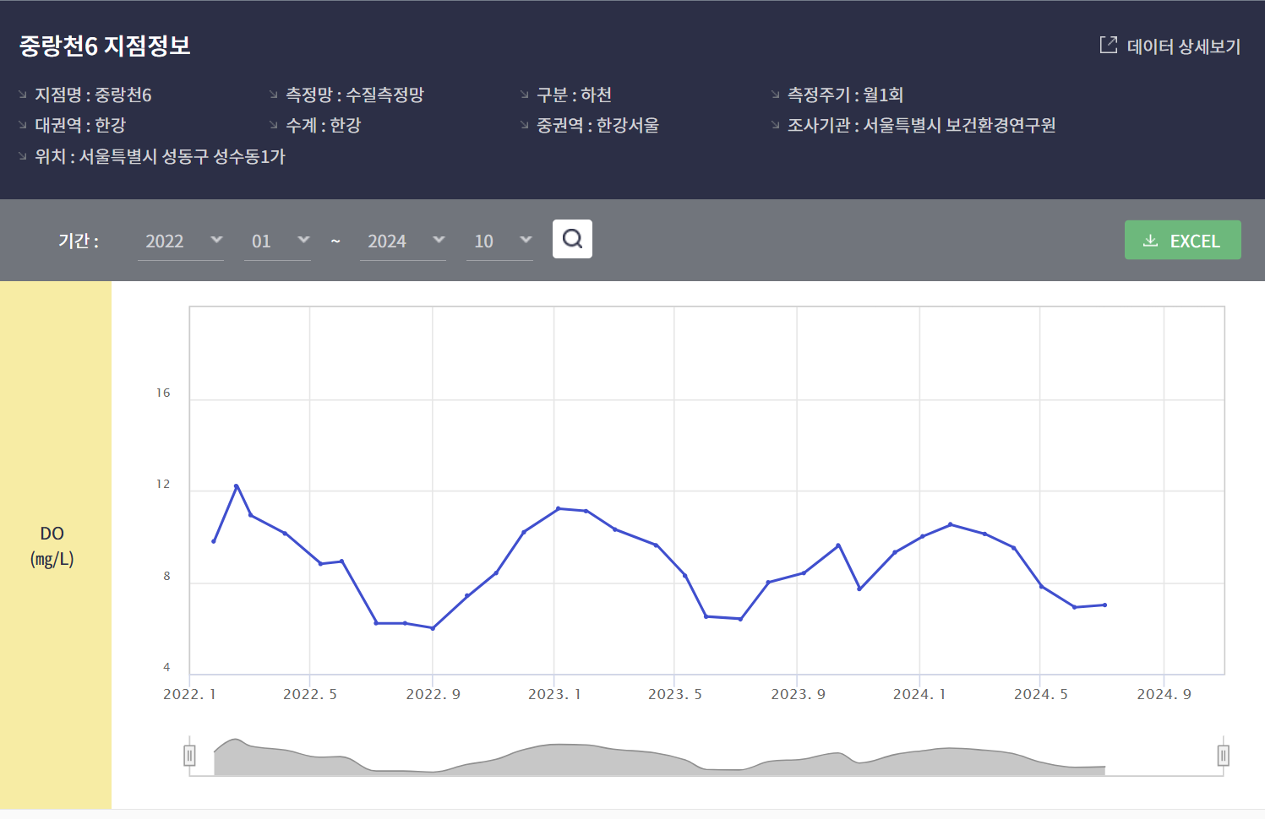

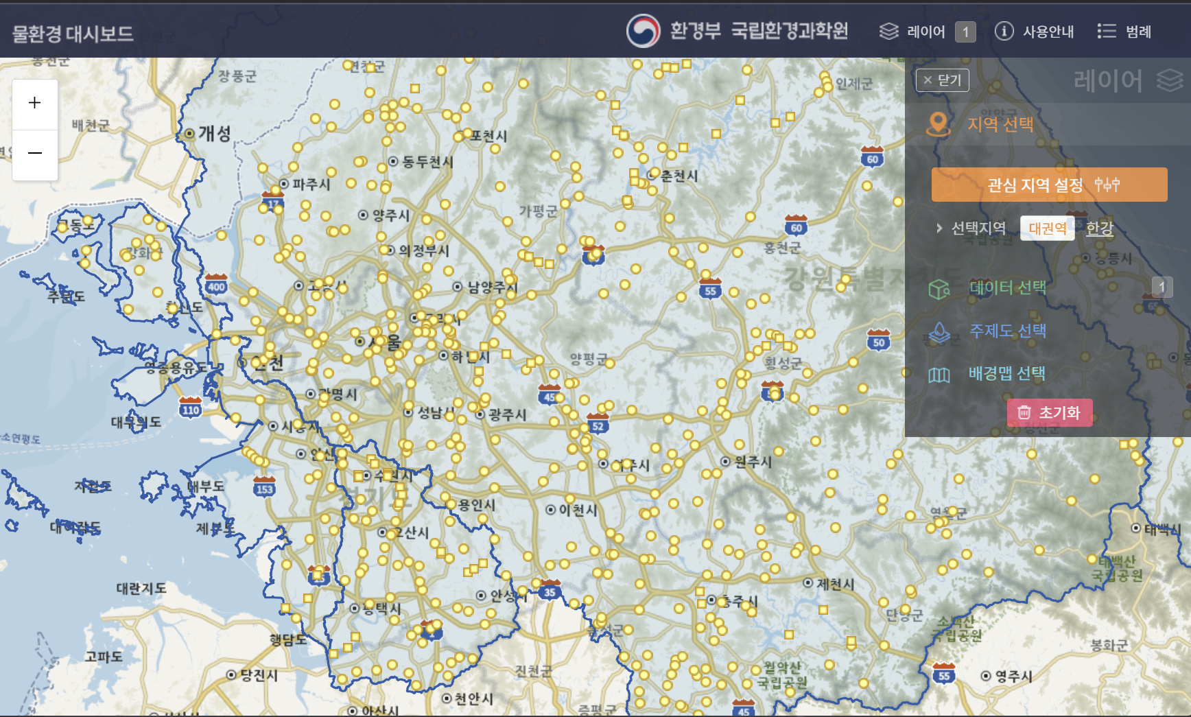

Min Kyu Han to Everyone 943 PM

Some frameworks that you can organize your thoughts and content for the poster into!

* Why -> How -> What

Background/Situation (Problem) -> Complication (Why this is a problem) -> Resolution (solution that you are providing)

Hypothesis -> Data (description of the data) -> Methodology -> Key Findings -> Conclusion

Tools that you can use to create your Poster and Prototype.

* Figma

* Adobe XD

* SketchSources that could be used.

as reference (later)

* <https://codepen.io/tag/mapS>

* <https://www.statista.com/topics/10886/water-industry-in-south-korea/#editorsPicks>

1. Benefits of an Interactive Water Quality Map

Creating an interactive map for water quality offers several benefits:

1. Public Awareness and Transparency:

People gain real-time insights into the water quality of their neighborhoods, empowering them to make informed decisions.

Builds trust by making government or environmental data accessible and understandable to the public.

2. Health Protection:

Alerts residents to areas where water may be unsafe for drinking or usage, helping them avoid health risks.

Provides timely information during emergencies, such as contamination or pipe bursts.

3. Environmental Advocacy:

Increases awareness about water pollution, promoting more sustainable water practices.

Citizens can report problems they notice, encouraging collaborative efforts to improve water infrastructure.

4. Data for Policymakers and Researchers:

Helps officials prioritize investments in regions with poor water quality or high leakage rates.

Aids researchers in tracking long-term trends in water quality, groundwater depletion, and infrastructure degradation.

5. Tourism and Business Impact:

Provides businesses, especially in food or tourism industries, with data to ensure they meet water quality standards.

Encourages tourism by showcasing regions with excellent water quality for recreational activities.

---

2. Why This is a Solution to the Problem of Outdated Pipes

1. Identifies High-Risk Areas:

By overlaying water quality data with pipeline information, officials can identify where aging pipes are causing contamination or water leakage.

Facilitates targeted repairs by focusing on the most affected areas instead of relying on periodic inspections.

2. Reduces Water Loss and Costs:

Leaky or old pipes contribute to high water wastage, especially in cities like Seoul where 5-6% of water is lost annually. Real-time monitoring helps spot leaks early, preventing further damage and loss.

Reduces the financial burden on municipalities by preventing major pipe failures through early intervention.

3. Encourages Infrastructure Modernization:

Publicly available data increases pressure on governments to modernize old pipelines and improve water management practices.

When residents see data about water quality issues, they are more likely to advocate for policy changes or investments in better infrastructure.

4. Promotes Smart Technologies:

Integrating smart meters or IoT-based sensors with the map system allows continuous data collection.

This data enables predictive maintenance, minimizing sudden disruptions caused by infrastructure failures.

By combining data visualization, public awareness, and targeted policy action, your interactive map serves as a practical tool to address water quality and infrastructure issues.

10/28 In-Person Meeting:

# General feedbacks/Comments:

* Aging pipe also causes sinkholes -> make clear for why we talk about flood, sinkhole
  + HIghlight that they are part of the same problem
* Make it clear for the parts of who presents what and be generally prepared for what we are going to say
* Poster itself is fine, how you present is IMPORTANT
  + Ppl r not going to read everything anyways, PINPOINT your points
* **Use bootstrap (framework?)**
  + Will build components for you
* Use ChatGPT
  + WE DEFINITELY DID!
  + Ask the issue in the code
* Do something on the website
* Think about who is using the map
  + Think about what they are going to see first, how they’ll reach the data, etc

Document things, take pics, make portfolio

* Organize ideas, prioritize the ideas to make sure we can do the main points
* Have a place where we can write our roles
  + Avatar, pics, names, etc
  + It’s to celebrate what you did
    - You want to celebrate the small wins since its what keeps you motivated
    - You are being held accountable for what you do
    - FEEL ACCOMPLISHED AND TAKE PRIDE!
* Add exactly what they are in the table, make it clear
  + Indicate whether normal, good, bad, etc
  + Add pipe date to the interactive map
  + Add frequency of flood, sinkhole, etc?
    - For correlation perhaps
* Make a small korean brochure version of the poster
  + Translate, put key points
* WE MUST LEAVE A STRONG IMPACT AS THEY WALK BY
  + 짧고굵지만, 임팩트있게
* Make words in the map Korean, like labels
* Add sources to the map
* Have the map show/explain/express the data written
* Add color key (eg: red-green)

# Presenting Tips:

* Hit all important points, make it storytelling type
  + Connect presentation tgt
* Think about the keywords you want to emphasize
  + Stats
  + 문제, 이십삼.이, like stats
* ALWAYS 100% better to show than saying
* English-Korean mixed presentation
* **How to make it a story:** 
  + Make it a situation -> talk about the specific case, direct the attention to what we are trying to prove
    - Focus on the poor quality of pipes
  + Talk about the complication
    - Explain why its bad
      * Drought, super bad problem in the future
        + Deterioration rate data is substantial
  + Move onto the solution
    - Poor infrastructure is a problem, no fix = more problem, therefore to fix this issue: solution A B C…
  + Talk about what we can do in the future
    - Not final
    - Tell that we can do this now, and mention things of what we can do in the future